Lab: Pressure -Temperature
Relationship in Gases
TheorY
Gases are made up of molecules that are in constant motion and exert pressure when they collide with the walls of their container. The velocity and the number of collisions of these molecules is affected when the temperature of the gas increases or decreases.
In this experiment, you will study the relationship between the temperature of a gas sample and the pressure it exerts. Using a online simulation (screen shown in Figure 1) from the University of Colorado: PHET Simulation - Gas Properties The volume of the gas sample and the number of molecules it contains will be kept constant. Pressure and temperature data pairs will be collected during the experiment and then analyzed. From the data and graph, you will determine what kind of mathematical relationship exists between the pressure and absolute temperature of a confined gas. You will also use your data to find a value for absolute zero on the Celsius temperature scale.
OBJECTIVES
In this experiment, you will
- Study the relationship between the temperature of a gas sample and the pressure it exerts.
- Determine from the data and graph, the mathematical relationship between the pressure and absolute temperature of a confined gas.
- Find a value for absolute zero on the Celsius temperature scale.

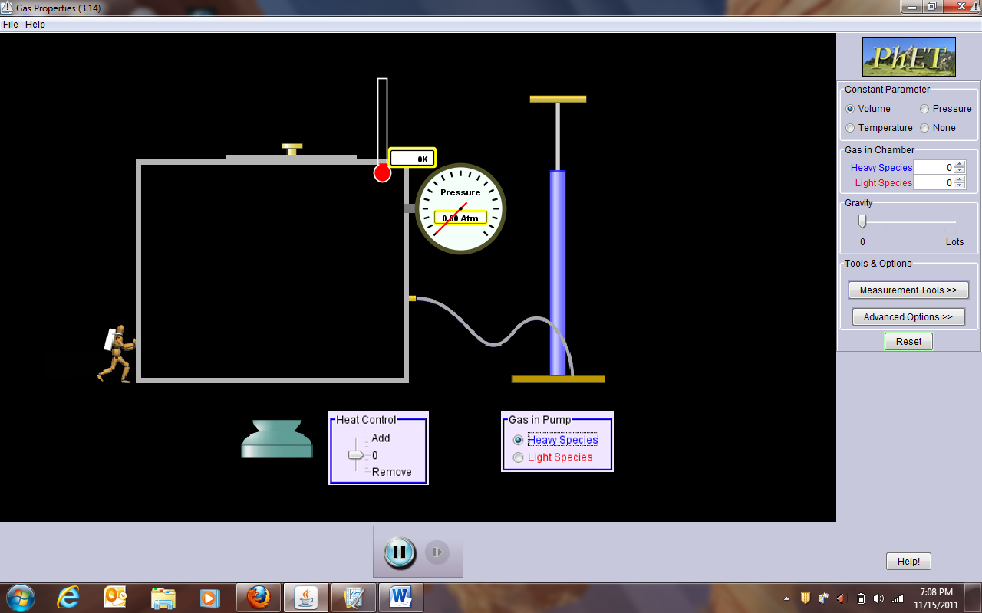
Figure 1
REFERENCES
https://opentextbc.ca/chemistry/chapter/9-2-relating-pressure-volume-amount-and-temperature-the-ideal-gas-law/

MATERIALS
Computer
Excel
PhET Simulation – Gas Properties

PROCEDURE
- Start up your browser and go to PHET Simulation - Gas Properties. Click on the “Run Now” button and after the simulation starts, select Volume for the Constant Parameter.
- We will generate data for both a heavy species and light species of gas molecules. Select “heavy species” to start with.
- Pump approximately 1 atm of pressure into the container.
- Record the Temperature in Kelvin (K) and Pressure in Atmospheres (Atm) in the data table. Calculate the Celcius (ºC) Temperature by subtracting 273 from the Kelvin Temperature.
- Add heat to the container, raising the Temperature by about 100 K. Record the new temperatures and pressure.
- Repeat the process until you have a total of 5 data values.
- Reset the simulation and select “light species”. Repeat steps 3 – 6.
Heavy Species |  |  | Light Species
T (ºC) | T (K) | P (Atm) | T (ºC) | T (K) | P (Atm)

- Open Microsoft Excel
- Enter the Heavy Species Kelvin Temperatures and Pressures in Excel Sheet 1. Enter the Light Species Kelvin Temperatures and Pressures in Sheet 2.
- Construct a fully labelled XY (scatterplot) for both sets of data. Save the “Heavy Species” as Graph1 & the “Light Species” as Graph 2.
(Pressure on the vertical axis & Temperature on the horizontal axis)
- Examine your two graphs and classify each graph of Pressure (atm) vs. Temperature (K) as either a proportional or inverse relationship (do this for both data sets):
- Add a linear trendline to both graphs and forecast backwards until the trendline intercepts with both the x and y axes.
- Paste a copy of the graphs of pressure vs. temperature (K) below. The fit lines should still be displayed on the graph.
Pressure vs Temperature (Kelvin) for Heavy Species and Light Species gas molecules:

PROCESSING THE DATA
1. In order to perform this experiment, what two experimental factors were kept constant?
The two experiment factors that were kept constant were choose an item and choose an item.
2. Based on the data and graph that you obtained for this experiment, express in words the relationship between gas pressure and temperature.
The gas pressure is choose an item to the Kelvin temperature.
3. Explain this relationship using the concepts of the kinetic theory of gases.
The pressure is proportional to the number of molecules per unit volume and to the average translational kinetic energy of the molecule. The Kelvin Temperature is a measure of choose an item.

4. Write an equation to express the relationship between pressure and temperature (K). Use the symbols P, T, and A.

Choose an item.
6. According to this experiment, what should happen to the pressure of a gas if the Kelvin temperature is doubled?
If the Kelvin temperature is double, the pressure of a gas should choose an item.

7. According to this experiment, what changes about the graph if the mass of the species is changed?
Click here to enter answer.

EXTENSION
The data that you have collected can also be used to determine the value for absolute zero on the Celsius temperature scale. Instead of plotting pressure versus Kelvin temperature like we did above, this time you will plot Celsius temperature on the y-axis and pressure on the x-axis. Since absolute zero is the temperature at which the pressure theoretically becomes equal to zero, the temperature where the regression line (the extension of the temperature-pressure curve) intercepts the y-axis should be the Celsius temperature value for absolute zero. You can use the data you collected in this experiment to determine a value for absolute zero.
1. Go to Page 2 in Logger Pro.
2. Enter the Pressure and Celcius Temperature for the Heavy Species Data Set.
3. Click the Linear Fit button, . A best-fit linear curve will be shown for the four data points. The equation for the regression line will be displayed in a box on the graph, in the form y = mx + b. The numerical value for b is the y-intercept and represents the Celsius value for absolute zero.
4. Paste the graph of temperature (°C) vs. pressure, with the linear fit line and its statistics still displayed below. Use Text Annotation from the Insert menu, to clearly label the position and value of absolute zero on the graph.
5. Compare your measured value of absolute zero with the known value of – 273 ºC by computing the percent error.
% error = Click here to enter %.

Graph of Celcius Temperature vs Gas Pressure for Heavy Species:
ConcluSION
After group discussion, write a conclusion summarizing the results of this experiment.

